EAST SUFFOLK COUNCILLOR’S REPORT
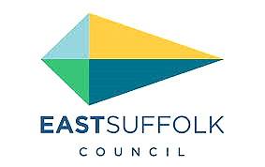
Cllr Stephen Burroughes – JULY 2022

- East Suffolk Council elects new Chairman for 2022/23
The Council has elected its new Chairman for the 2022/23 municipal year. Jenny Ceresa, who represents the Carlton Colville ward, was appointed to the role at the annual meeting of the Full Council.

Cllr Ceresa takes over from Oulton Broad councillor, Keith Robinson, who was elected in September 2020 and chaired the council during the Covid-19 pandemic.

She was voted in as councillor for Carlton Colville in 2015 and has since served as a member of the planning committee and scrutiny committee. She was also elected to Suffolk County Council, for Lowestoft South, in 2017, and chairs the county council Development and Regulation Committee. Cllr Ceresa's deputy for the 2022/23 municipal year will be Martlesham and Purdis Farm ward councillor, Chris Blundell.

- First light weekend caps incredible summer for Lowestoft
With the return of First Light Festival and several major projects approaching completion, Lowestoft is enjoying incredible summer, and East Suffolk Council is playing a leading role. Tens of thousands of people attended the two-day First Light Festival, organised by First Light CIC and held on Lowestoft’s award-winning South Beach. East Suffolk Council supported the 24-hour event with £200,000 of funding agreed last September. The funding helped ensure that an exciting programme of arts activities, including music, dance, theatre and performance, was available for everyone to enjoy. The weekend also saw the opening of the refurbished East Point Pavilion as a contemporary food and entertainment venue, owned by East Suffolk Council and operated by First Light. The beach also has a new boardwalk, enabling people with disabilities to access the South Beach more easily, thanks to a scheme led by the Waveney Disability Forum, working closely with East Suffolk Council. Additionally, 72 contemporary beach huts, known as Eastern Edge, are approaching completion on the seafront.

- East Suffolk Free Wi-Fi launches in Felixstowe
Following a successful launch in Lowestoft and as part of a range of exciting digital projects taking place across East Suffolk, free-to-use public Wi-Fi has launched in Felixstowe.  The East Suffolk Digital Towns programme will digitally transform market towns through the installation of free public Wi-Fi, digital footfall counters and town marketing platforms, alongside a business support programme called the Digital Springboard. | 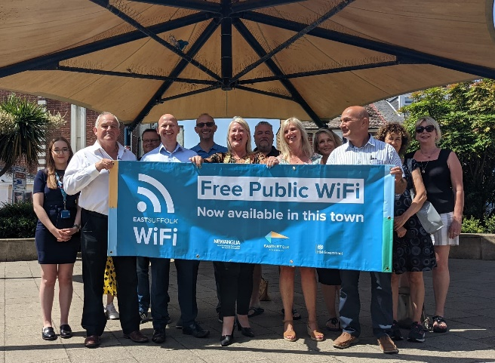
Supported by funding from the Getting Building Fund and New Anglia Local Enterprise Partnership’s Innovative Projects fund, the new technology was piloted in Framlingham in 2019 and has now been launched in the main shopping areas of Felixstowe, as well as the seafront areas, with other market towns to follow later this year. New technology will enable the council to understand the number of visitors to the town, the busiest periods, the average time people spend in the town centre, and much more. This will enable the Economic Development Team to provide tailored support for local businesses and provide data-based evidence to support other ongoing projects.

East Suffolk is also working in partnership with an interactive walking app provider, Go Jauntly, to develop outdoor adventures across 12 towns and villages. Following launches in Lowestoft and Felixstowe, East Suffolk Free Wi-Fi is provisionally scheduled to be available in Woodbridge, Southwold, Beccles, Bungay, Halesworth, Aldeburgh, Leiston and Saxmundham by October 2022.

- Pakefield residents have say on options for coast
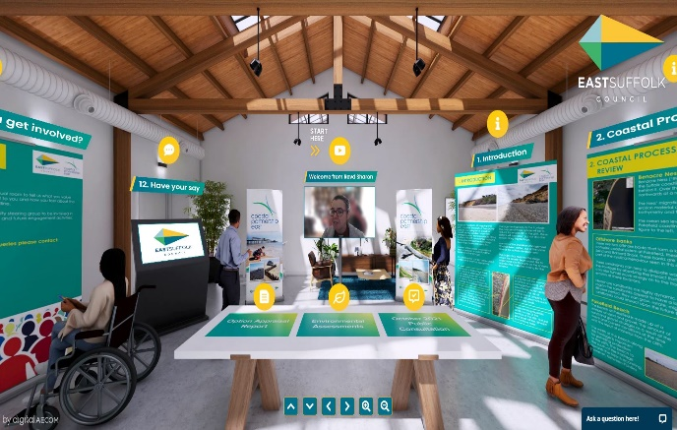 | Pakefield residents were invited to give their views on the options for managing the future of the coast, through both an online visitor centre and a face-to-face event.  Coastal Partnership East held an event on 11 June, at Pakefield Church Hall, to enable the community to find out more about options for managing the continuing erosion and future of the coastline.
The Pakefield Virtual Visitor Centre, which uses gaming technology developed during the pandemic, will also be available for other people to access information. The Visitor Centre has been updated with consultation information, while an accompanying questionnaire will be open until 30 July.

- Distinctive benches unveiled at Langer Park
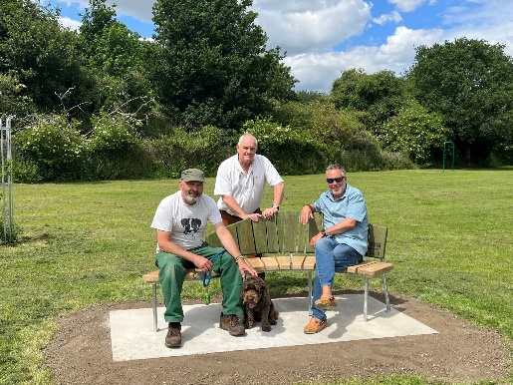 | Visitors to Felixstowe’s Langer Park are now able to enjoy the use of two newly unveiled and uniquely designed benches, installed as part of a series of improvements commissioned by East Suffolk Council.  Each was handmade by furniture designer and maker Tim Germain, using oak felled locally on a needs-must basis at an area of mature woodland, called The Grove, by Greenways Countryside Project volunteers.

The benches’ creator (pictured left with his dog, Chocco) was joined for their official unveiling by Eastern Felixstowe councillors Mark Jepson (right) and Steve Wiles (centre). The unveiling is just the latest element of a wider project to improve the park by creating a welcoming, green space that can be used by residents and visitors to relax, exercise, catch up with family and friends, or admire the local wildlife.

- Looking out for Landguard – a new organisation arrives
With its charitable status now approved, the Landguard Trust is in the process of taking over much of the management of the Landguard Peninsula at Felixstowe.
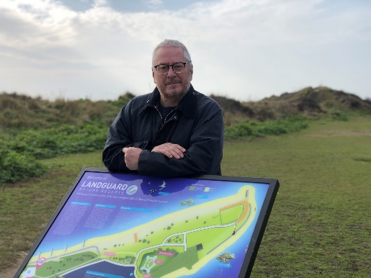 | The Trust, which replaces the Partnership that has been carrying out a similar role since 2008, is working with stakeholders to take Landguard forward in the next stages of its evolution.  With its Grade I listed Fort, local history museum, nature reserve, and the adjacent Port of Felixstowe and Harwich Haven, the Trust has three main themes, which naturally focus on Landguard’s heritage, nature and maritime elements.
Conservation and learning are key objectives for the Trust, as well as continuing Landguard’s development as a visitor destination and community volunteering hub. David Gledhill, Landguard Trust Chairman (pictured), said the Trust will have a greater focus and flexibility to take Landguard forward with the support of all its main stakeholders, including East Suffolk Council, English Heritage and existing volunteer groups that have been doing great work over the years.

- Residents invited to have say on new planning document
East Suffolk residents are invited to have their say on a new planning document covering small-scale residential development in the countryside. A consultation on the draft Housing in Clusters and Small-Scale Residential Development in the Countryside Supplementary Planning Document (SPD), which provides guidance on the development of small-scale housing of up to five dwellings, was launched on Friday 17 June. The draft SPD covers a range of topics including an outline of the necessary characteristics for sites to be appropriate for development, considerations on the potential impact on character of the area, the requirements for public engagement and how these policies relate to other policies in the Suffolk Coastal Local Plan and the Waveney Local Plan.

All comments received by 5pm on 5 August will be considered and taken into account when finalising the Housing in Clusters and Small-Scale Residential Development in the Countryside SPD, which will be adopted later in 2022. Once adopted, the SPD will be a material consideration in determining planning applications. You can view and comment on this consultation at eastsuffolk.gov.uk/planning-policy-consultations.

- Community Safety Ambassador events well received by participants
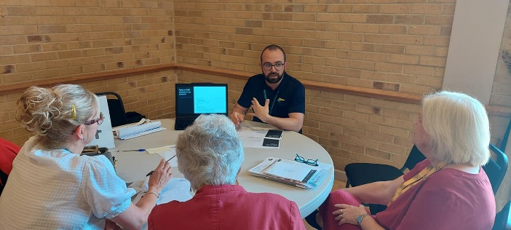 | Dozens of people benefitted from attending two Community Safety Ambassador events staged by this Council.  The events brought together professionals from a range of organisations to share knowledge with people who regularly work to address the needs of older residents.
A total of 44 people left feedback following the events, with everyone agreeing that the content was practical to their needs and interests; that the training will be useful to share in their communities, and that the events increased their knowledge of everyday safety issues. The awareness raising events were a chance for individual volunteers and organisations to pick up free advice on numerous topics, from home security and personal safety, to preventing the risk of falls around the home.

Both Community Safety Ambassadors events were organised by East Suffolk Council and funded by an underspend in councillors’ collective Enabling Communities Budgets for 2021/22. The events took place at the Hotel Victoria, in Lowestoft, and the Kesgrave War Memorial Community Centre, in Kesgrave.

In attendance were representatives of Suffolk Constabulary, Suffolk Fire and Rescue Service, Suffolk's Warm Homes Healthy People project, Suffolk Trading Standards, the Cassius digital care technology team and East Suffolk Council’s antisocial behaviour lead.

- Improved beach access ramp installation scheduled for late summer
Work is set to begin at the end of the summer season on the installation of a replacement ramp to improve beach access in Felixstowe. The ramp will provide a safe escape route in the event of the sea wall gates being closed in bad weather.

Planning permission has already been granted to replace an existing ramp over the sea defence wall, linking the pavement along Sea Road and Orford Road to the beachfront. The site is located within Flood Zone 2, southeast of the newly constructed Martello Café, positioned to the northern extent of Martello Park, south-west of 'Orford Shelter'. Recent global supply chain issues have led this Council to suspend the launch of on-site construction work until after the peak summer visitor season in order to limit the impact on local businesses, nearby beach hut owners and other members of the public.

The on-site work is scheduled to begin immediately after the school holidays at the beginning of September 2022.

- Supporting older residents through slipper swap
Older residents living in Beccles, Bungay, Halesworth and the surrounding villages are invited to exchange their old, worn-out slippers for free. Following the success of a similar project in the Carlton Colville area last year, the Beccles, Bungay, Halesworth and villages Community Partnership is now offering older people the opportunity to swap their old slippers for a brand-new pair in a new ‘slipper swap’ project. Many older people are keen to stay independent at home, however walking indoors in worn-out slippers, barefoot or in socks can increase the risk of falls, slips and trips.
Residents can swap their slippers for a new pair which have special design features to help prevent falls, such as secure fastenings and robust soles. Where necessary, residents will also be linked to other sources of support which could be beneficial. The Slipper Swap project is being delivered in partnership with East Suffolk Council’s Communities Team, parish and town councils and local groups and organisations.

- Behind the scaffolding at Lowestoft’s historic Post Office building
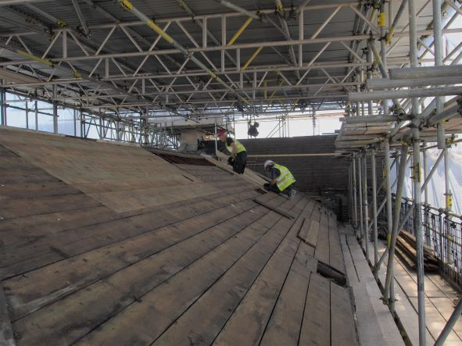 | A skilled team of builders, conservators and craftspeople are forging ahead with restoration work to the outside of Lowestoft’s former Post Office building.  The intricate process of repairing the Grade II listed Victorian building’s exterior began in January – with financial backing from the Council and Historic England, as well as the government’s Towns Fund.

Delivered through the London Road, Lowestoft Heritage Action Zone programme, and overseen by lead contractor RG Carter, the renovation project also features the skills of East Suffolk based company and specialist architectural conservators, Aldis and May Ltd. The project team also comprises lead architects Chaplin Farrant, conservation architects Kings and Dunne, and structural engineers, The Morton Partnership. Along with air lime repointing, consolidation and mortar repairs to save as much of the original stone as possible, the work currently involves the removal of algae, lichens, sulphation crusts and dirt, as well as painstakingly stripping back a linseed oil surface coating applied to the building for weather protection.

Elsewhere, cement has been removed from areas patched-up over the years, and a sacrificial sheltercoat applied to protect the more vulnerable areas of masonry. On the seventh storey of scaffolding, roof tiles have been stripped away before being replaced and reinsulated.

- Surveys and consultations
As always, we want to encourage participation in surveys and consultations, as feedback from people in East Suffolk is invaluable and helps us ensure we’re making the right decisions for our communities.

- Draft Housing in Clusters and Small Scale Residential Development in the Countryside Supplementary Planning Document
Providing further guidance on the development of small scale housing, of up to five dwellings, in the countryside. The consultation is open until Friday 5 August at https://eastsuffolk.inconsult.uk/Draft_Housing_Clusters_SPD/consultationHome

Cllr Stephen Burroughes
Member for the Kelsale & Yoxford Ward
Cabinet Member for Customer Services, ICT & Commercial Partnerships
Twitter @CllrStephenB

